SEPTEMBER and OCTOBER NEWSLETTER

AM SESSION

**Curriculum News**

I would like to welcome you and your child to my classroom. The preschool staff and I are simply delighted to be your child’s teachers for this school year. It has been an absolute pleasure to see some new faces, as well as some familiar faces from the students in class. Now that the class has finished its second week of school, I am proud to inform you that all the students have done very well with adjusting to the classroom environment and routine. We are **ALL** off to a good start and thus, the class has already started to learn some components of the “Tools of the Mind” Curriculum, which includes the “Mystery Question”, “Timeline Calendar”, “The Weather Graph”, and “Freeze Dance. In conjunction with the “Tools of the Mind” Curriculum, the class will be participating in an activity entitled “Mat Man” which is a fine-motor activity to teach children how to draw a person with a least 3-5 recognizable body parts. In addition, the class will learn about the colors of red, orange, and black and the shapes of circle and square. Also, the class will learn how to tear strips of construction paper with our little hands. The class will participate in physical education class with Mrs. Horn on Mondays, music class with Mr. Heath on Thursdays, and speech/language group with Mrs. Pool on Wednesdays for this school year. The first theme that the class will be learning about will be **“The** **Farm”** in October. As a result, the class will be busy making props for the “Farmer’s Market” and a corn field, as well as other art projects. As part of the “Tools of the Mind” Curriculum, the classroom has been divided into six different learning centers. These learning centers are the following: **Art, Blocks, Dramatic** **Play, Literacy, Science, and Table** **Toys.** For each theme, these learning centers will represent a different location component of it. For example, for the theme of **“The Farm”**, the learning centers will be the following:

**Art**-a variety of farm art projects. “On the Farm” play-dough mats and

play-dough, and farm easel paintings.

**Blocks**-a barn and farm animals.

**Dramatic** **Play**-a farmers market and cornfield.

**Literacy**-a variety of pre-reading and pre-writing material.

**Science**-planting and sorting a variety of vegetable seeds in the

sand table.

**Table** **Toys**-a variety of “hands-on” farm manipulatives.

**Important Dates to Remember**

**Friday, September 7th**

Happy 4th Birthday Eva!

**Wednesday, September 12th**

Scholastic Book Fair

9:45 A.M.-10:15 A.M.

**Thursday, September 13th**

Open House

5:45 P.M.-6:15 P.M.

**Friday, September 21st**

Scholastic Book Order Due

**Saturday, September 22nd**

First Day of Autumn

**Friday, October 5th**

Scholastic Book Order Due

**Monday, October 8th**

Columbus Day-No School

**Thursday, October 18th**

Class Photographs

Please have your child wear a **SMILE** to school.

**Wednesday, October 31st**

**Happy Halloween**

**Fall Festival Celebration**

10:30 A.M.-11:30 A.M.

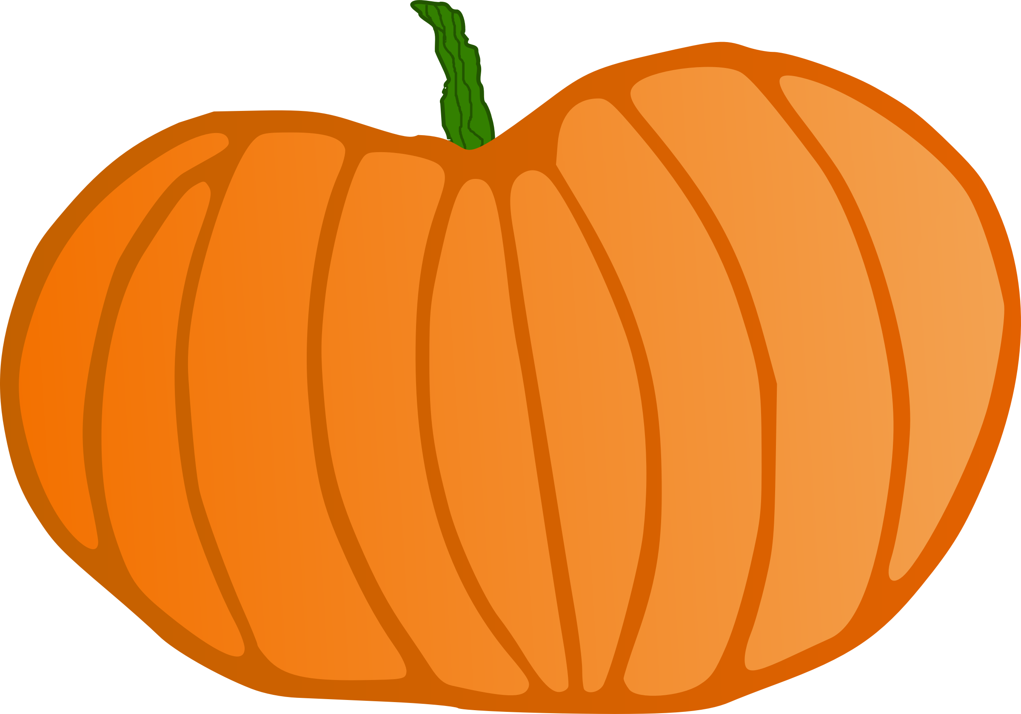

I have designed and published a website for my preschool classroom and it will be added to the Memorial Elementary School website ASAP. The website will include the following information:

**Welcome**

**Meet the Teahcers**

**Pre-K Information**

**News**

**Parent Resources**

**Contact Information**

**(Please see reverse side.)**



The preschool program has a **“twitter”** account so if you would like to know what is happening in Miss Monroe’s classroom please follow us @PreKMemorial.

**Home-School Connection**

As the class learns about the theme **“The Farm”**, the following is a list of apps, books, and fingerplays/songs associated with it. These educational activities will assist your child in making the home-school connection with this theme.

**Apps**

**Hay Day**

**Happy Little Farmer**

**PEEKABOO** **BARN**

**Books**

**FARM** **ANIMALS**-Wade Cooper

**MRS.** **WISHY-WASHY’S** **FARM**-Joy Cowley

**BARNYARD** **BANTER**-Denise Fleming

**FARMING**-Gail Gibbons

**TEN** **RED** **APPLES**-Pat Hutchins

**Fingerplays/Songs**

**BINGO**

Super Simple Songs

**Old MacDonald Had a Farm**

Super Simple Songs

**SCARECROW Song**

The Learning Station

**The Animals on The Farm**

Super Simple Songs

**Way Up High in an Apple Tree**

The Learning Station

The links below will be e-mailed to you so that you and your child can enjoy singing these farm and Halloween fingerplays and songs together.

<https://www.youtube.com/playlist?list=PLUf6yyWRRPWy5yQlMX-5oMSL9sNKngkWp>

https://www.youtube.com/playlist?list=PLUf6yyWRRPWx-nUDOdaJYcVOv-8Y11tdF

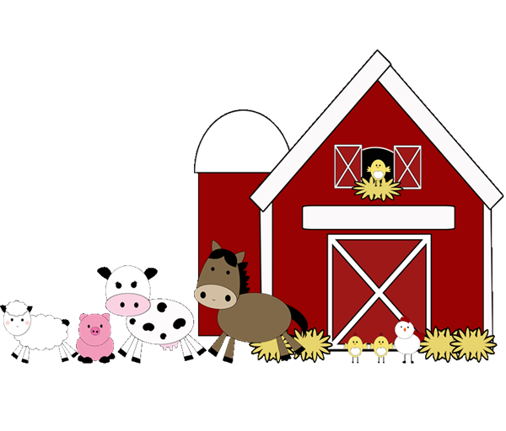

**Classroom Information**

**Traveling School Folder**

Please remember to check your child’s traveling school folder each day that he/she attends school. This will allow important school information to be transported to and from school in a timely manner.

**Snack**

Please send in one snack and drink for your child to eat and drink in a timely manner (10 minutes) each school day.

**Extra Change** **of** **Clothes**

Please send in an extra change of clothes for your child labeled with his/her name if it becomes necessary for him/her to change clothes. In addition, now that the seasons have changed from summer to autumn please remember to dress your child according to the weather. Also, please try to dress your child in clothes (i.e., leggings, sweatpants, etc.) that will encourage and develop him/her to become independent with his/her clothing skills. Also, now that the season of autumn is here please remember to dress your child with clothing that is appropriate for the weather.

**Objects/Toys**

Please do not send objects and/or toys to school with your child for they are distractions for him/her and his/her classmates who are trying to learn.

**FALL FESTIVAL CELEBRATION**

The class will be having a FALL FESTIVAL CELEBRATION on Wednesday, October 31st from 10:30 A.M.-11:30 A.M. Activities for this celebration will include an art and craft activity, a story, a game, and a snack – “Snack in a Bag”. Your child will decorate a paper bag at school and it will be sent home with him/her for you to send a special snack to school. The class needs fall and Halloween stickers. If you can donate stickers please do so by Friday, October 12th. Your child will be able to wear a Halloween costume (please do not send in a mask) for the Halloween parade. I will let you know the time of the Halloween Costume Parade ASAP. If you plan to attend the parade it will occur in the cafeteria.

**THANK YOU!**

I would like to **THANK** **YOU** for donating books to the classroom library from the Scholastic Book Fair. All the books are a wonderful addition to the classroom library. The students have enjoyed listening to them, as well as “reading” them too. Also, I would like to **THANK** **YOU** for donating items (i.e., disinfectant wipes, Kleenex, cream of tartar, bottled water, etc.) to the class.

